General:

Standard loading panel in all pages – center aligned

200X300 Size

Remove grid title – applicable in all areas

Breadcrumb – separator change to arrow (Unicode)

*Menu bar:*  
font – 14px

Background: ??

Breadcrumb: reduce top/bottom gap - 50% both sides

Footer: Color change, reduce height, position – relative

Top RHS: Notification icons – pending orders, pending review approvals

DASHBOARD

Bar chart – Weekly Sales summary

Pie chart – Root category wise sales

Latest Products- 10 products, link to open ind.product, all products

Latest Orders- 10 orders, link to open ind.order, all orders

Reorder Items – based on critical level rating

Products:

Tab caption font size increase

Remove tab header blue strip

Toolbar button - size try to increase by 50%, need to fit in existing area

Toolbar button - Vertical align middle

LHS Navigation -

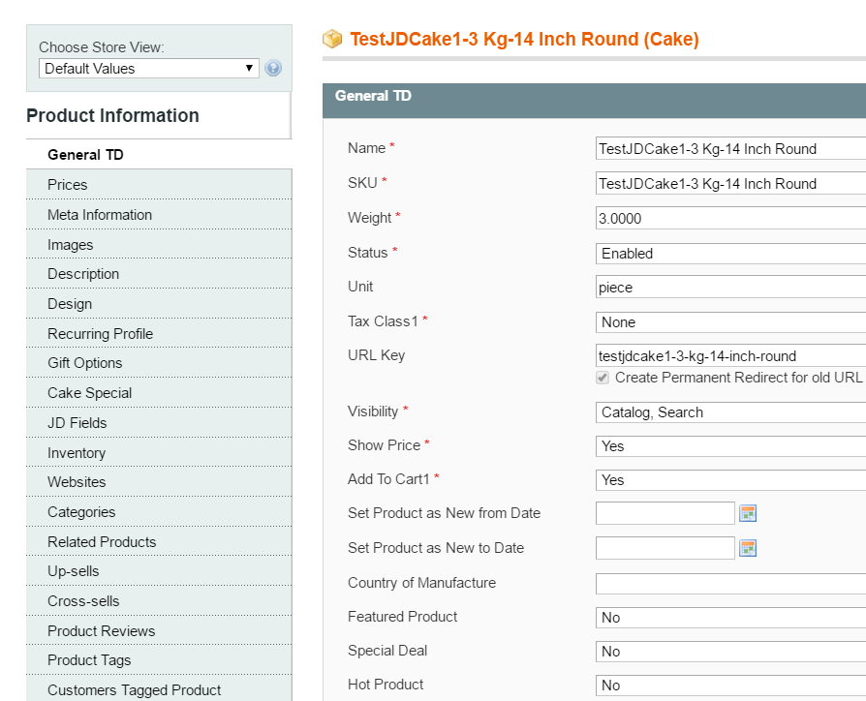

Grid background color change -??

Product type & attribute set

Split LHS Navigation: **Configuration** – Settings, **Base Product Info** – General, Description + product tags, Price, Inventory. **Additional Product Info –** Images, Other attributes, associated products, related products, Ratings & reviews